Jenkins Assignment Questions :

1. While check out the code from GitHub Repository what are mandatory steps which we need to follow in Jenkins . Please see the below Image and explain do we need really provide credentials while checkout code?

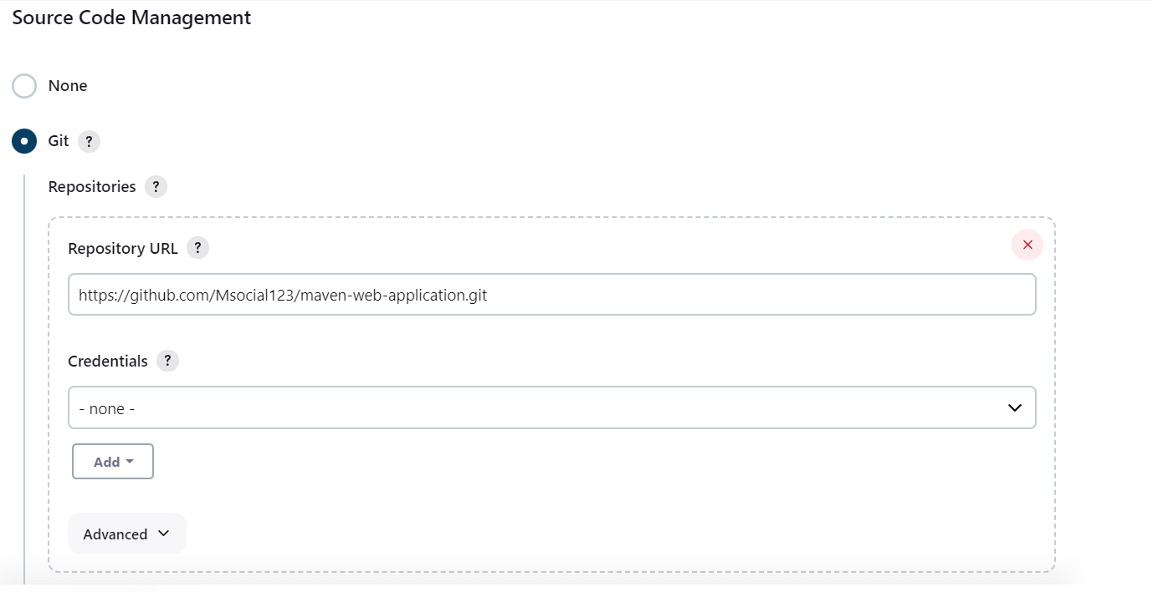

1. I would like to trigger my pipeline automatically when software development push the code into GitHub Repository. Please see the below image and explain?

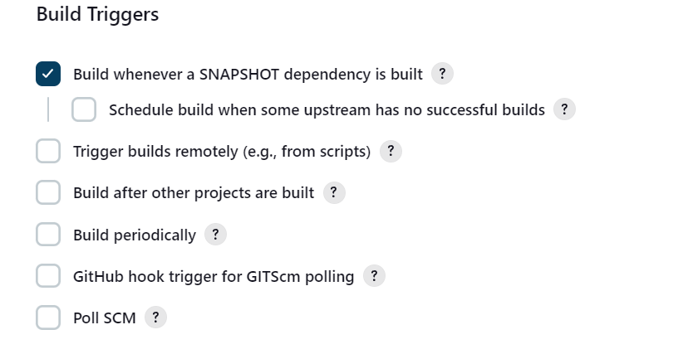

1. If I would like create upstream and downstream jobs through jenkins. which option do I need to choose from the list?

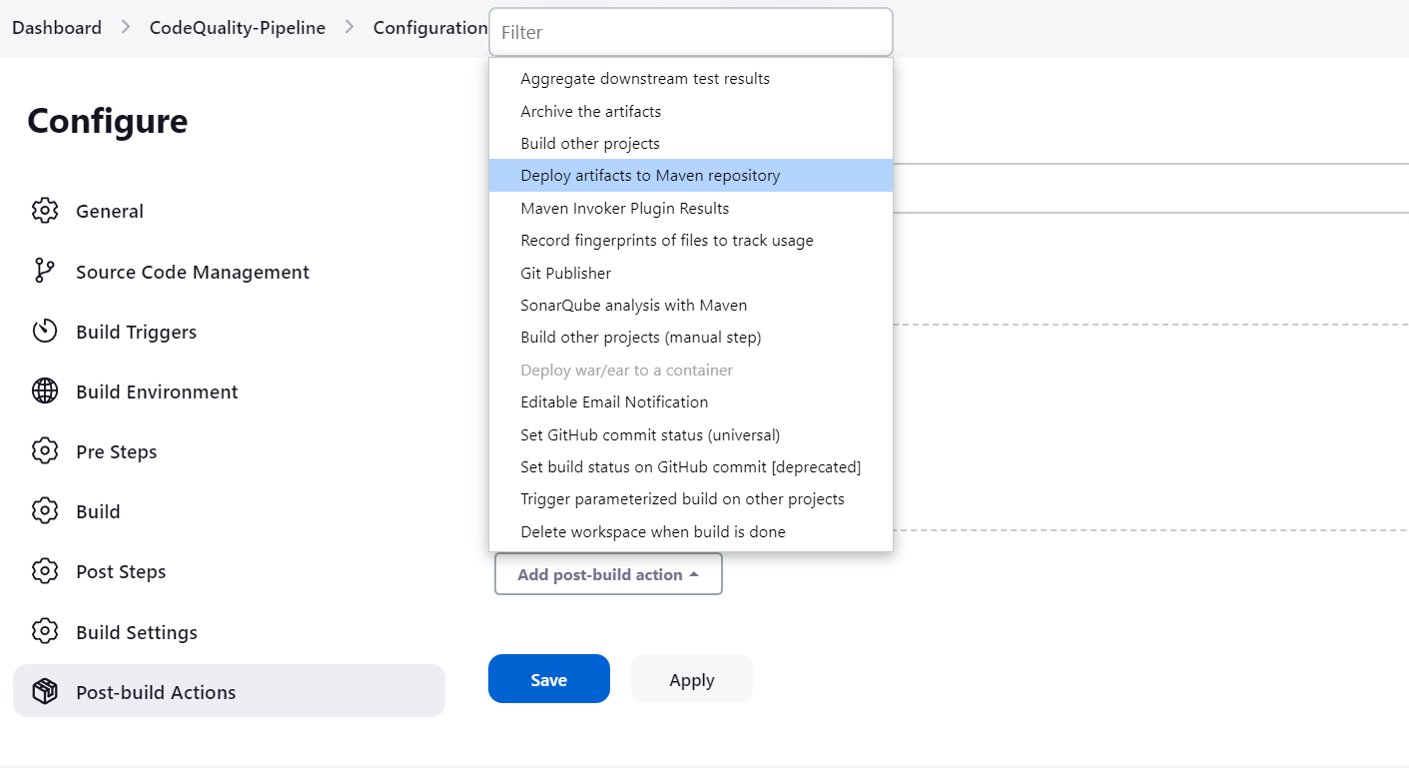

1. Need to deploy the application after the build how can we get Artifact ID automatically deploy into the tomcat container? What is necessary steps which we need to follow please see the below and explain?

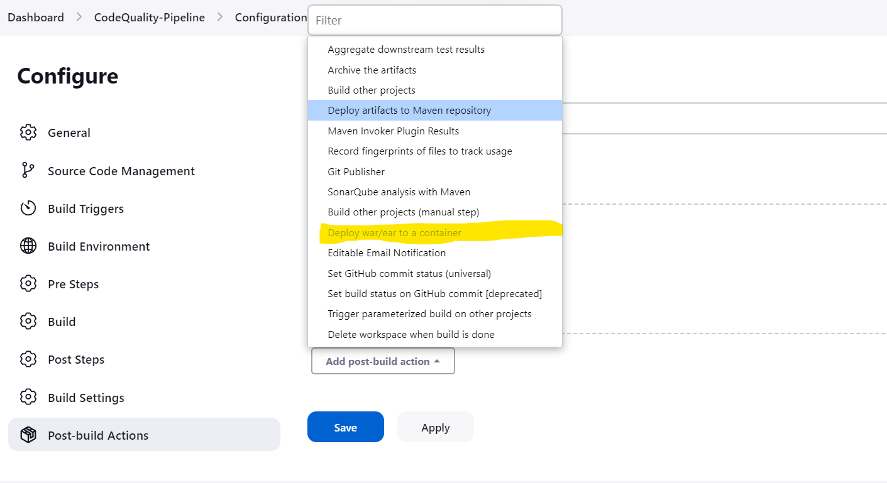

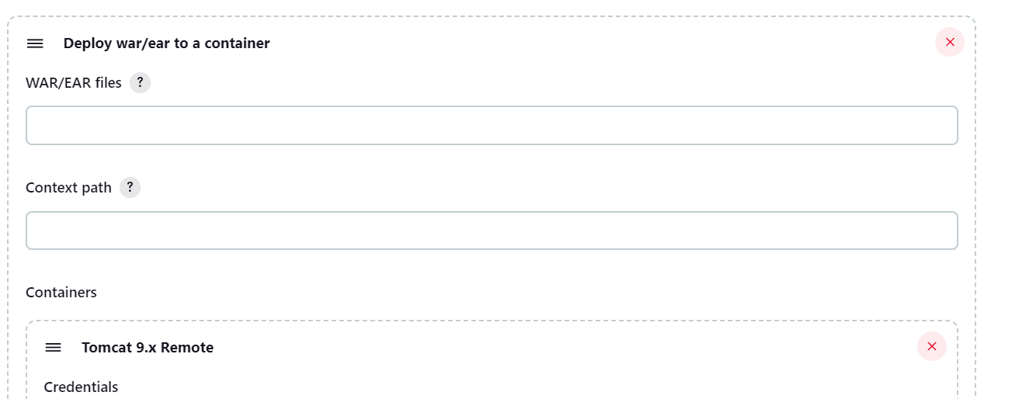

1. How do you integrate the Nexus to the Jenkins and which plugin do we need to install?
2. What is difference between GitHub Web hook and Poll SCM ? When I would to run the pipeline on a schedule basis which option do I need to opt out?

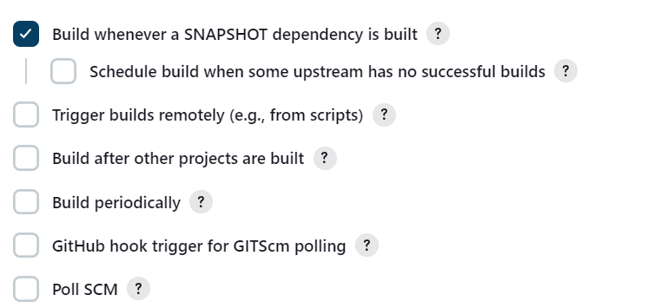

1. See the below Groove Script and explain where do you configured tools like docker,Maven ?

node {

stage('Preparation') { // for display purposes

// Get some code from a GitHub repository

git 'https://github.com/jglick/simple-maven-project-with-tests.git'

// Get the Maven tool.

// ** NOTE: This 'M3' Maven tool must be configured

// ** in the global configuration

}

stage('Build') {

// Run the maven build

withEnv(["MVN_HOME=$mvnHome"]) {

if (isUnix()) {

sh '"$MVN_HOME/bin/mvn" -Dmaven.test.failure.ignore clean package'

} else {

bat(/"%MVN_HOME%\bin\mvn" -Dmaven.test.failure.ignore clean package/)

}

}

}

stage('Results') {

junit '**/target/surefire-reports/TEST-*.xml'

archiveArtifacts 'target/*.jar'

}

}

1. While writing declarative pipeline which is the mandatory fields that we need mention? See the below script and Identify? What is the expected error ?

pipeline {

agent any

tools {

// Install the Maven version configured as "M3" and add it to the path.

maven "M3"

}

stages {

stage('Build') {

steps {

// Get some code from a GitHub repository

git 'https://github.com/jglick/simple-maven-project-with-tests.git'

// Run Maven on a Unix agent.

sh "mvn -Dmaven.test.failure.ignore=true clean package"

// To run Maven on a Windows agent, use

// bat "mvn -Dmaven.test.failure.ignore=true clean package"

}

post {

// If Maven was able to run the tests, even if some of the test

// failed, record the test results and archive the jar file.

success {

junit '**/target/surefire-reports/TEST-*.xml'

archiveArtifacts 'target/*.jar'

}

}

}

}

}

1. Explain the steps how to create a Jenkinsfile through Jenkins how to it is going to help for the CI/CD pipeline?
2. See the below image explain the steps how to create CI/CD pipeline view ?

